**Static Control Flow**

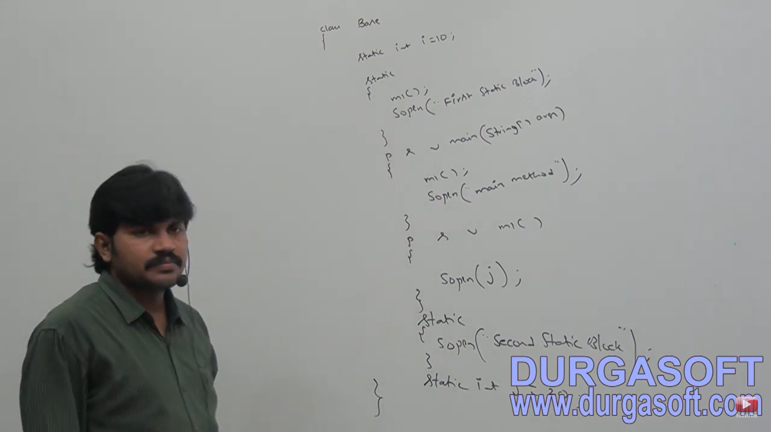

In which order the execution will be there

1. Identification of static members from top to bottom.
2. Execution of static variable assignments and static blocks from top to bottom
3. Execution of main method.

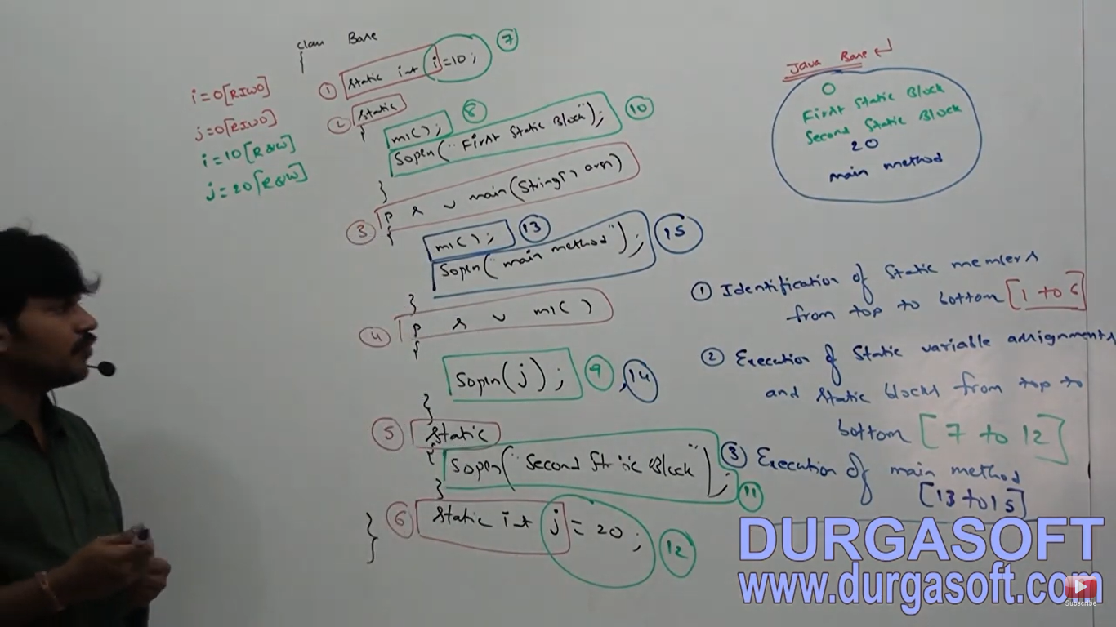

Static control flow

Whenever we are executing a java class the following sequence of steps or activities will be executed as part of static control flow:

1. Identification of static members from top to bottom
2. Execution of static variable assignments and static blocks from top to bottom
3. Execution of main method

**Read Indirectly Write Only**

If we are trying to read a variable inside a static block that read operation is called **direct read.**

If we are calling a method and within that method if we are trying to read a variable that reads operation is called **Indirect read**

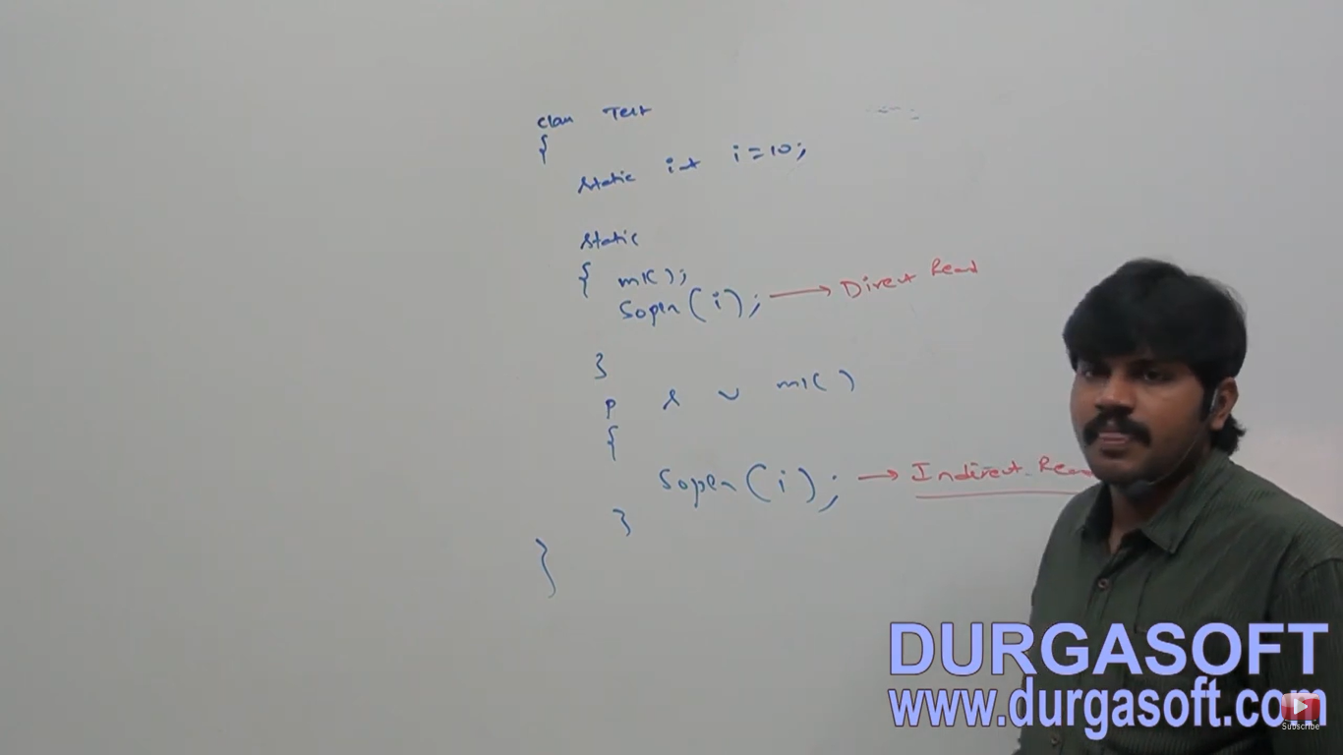

If a variable is just identified by the JVM and original value not yet assigned then variable is said to be in Read Indirectly write only state (RIWO).

If a variable is in RIWO state then we can’t perform direct read but we can perform Indirect Read.

If we are to trying to read directly then we will get compile time error saying **IllegalForwardReference**

